s1091551_HW1

Personal Blog

˙Install server

-apache

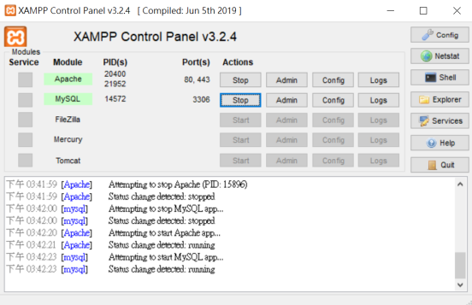

˙Change port: 因80port可用，故沒改port。

˙Error page (http:// 192.168.43.23/aaa(任何亂碼皆行))

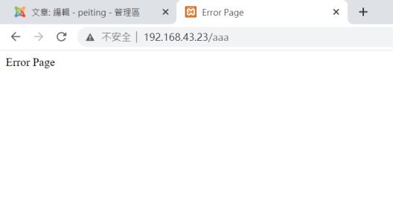

-php (http:// 192.168.43.23)

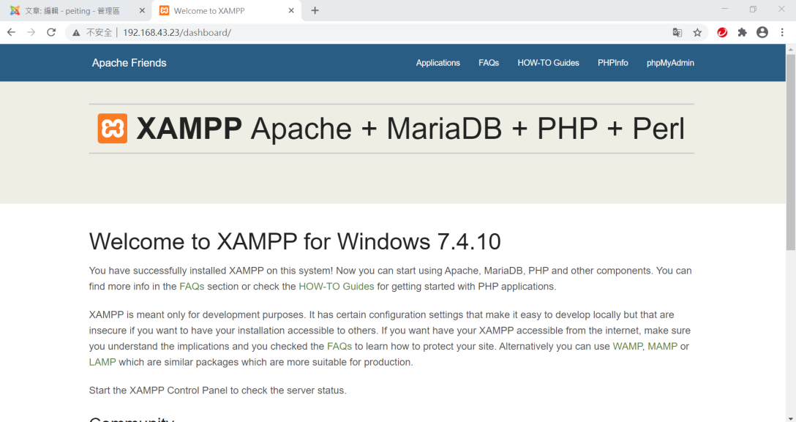

-MySQL

˙Login with password (http://192.168.43.23/phpMyadmin)

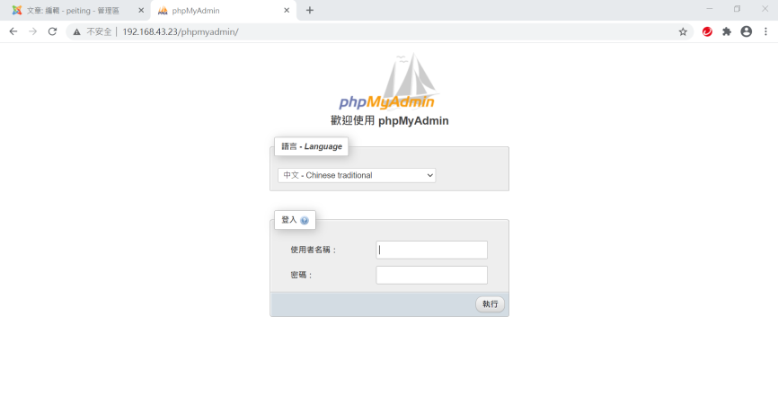

˙add an user

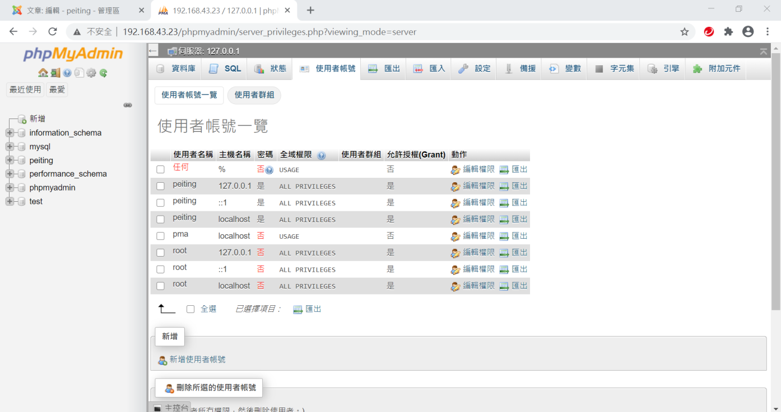

˙Install joomla

-Install joomla

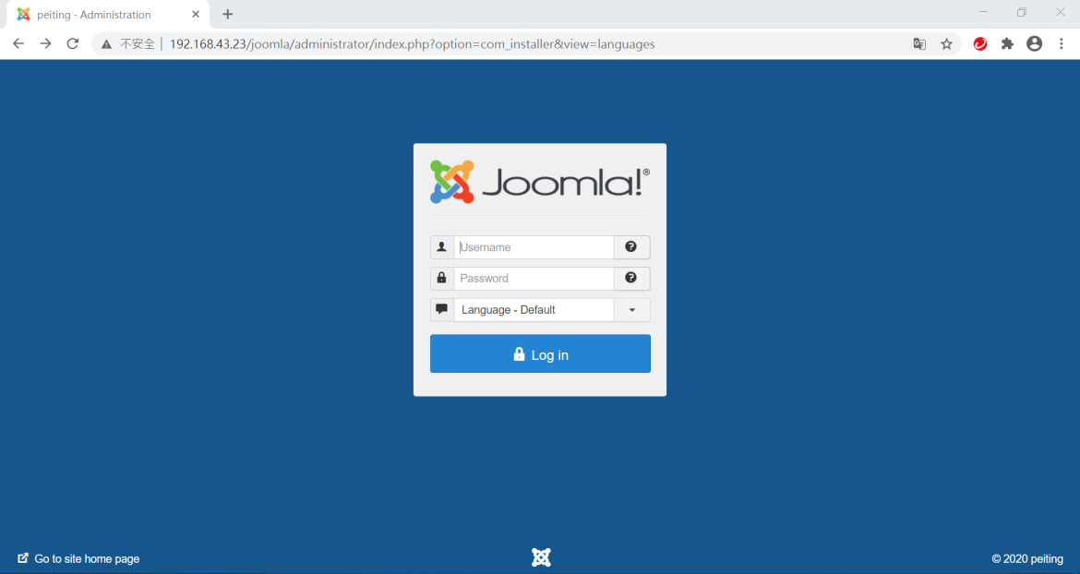

-Change joomla template (download free template)

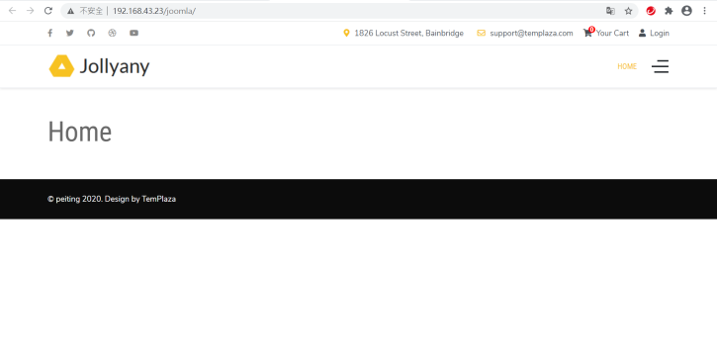

-Install language(Traditional Chinese) 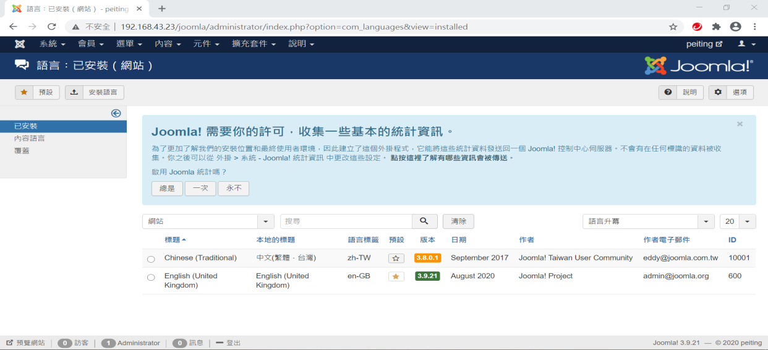

˙Scan website

(http:// 192.168.43.23/joomlaadministrator/index.php)

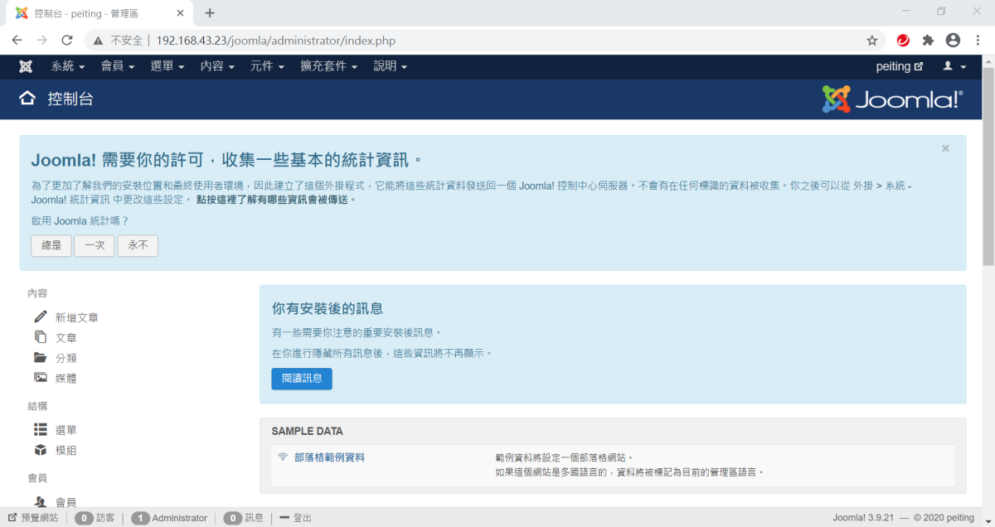

˙Post an article on the Blog

-Self introduction

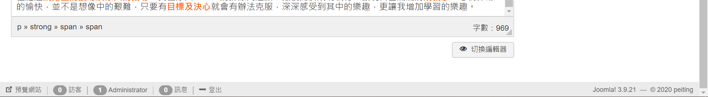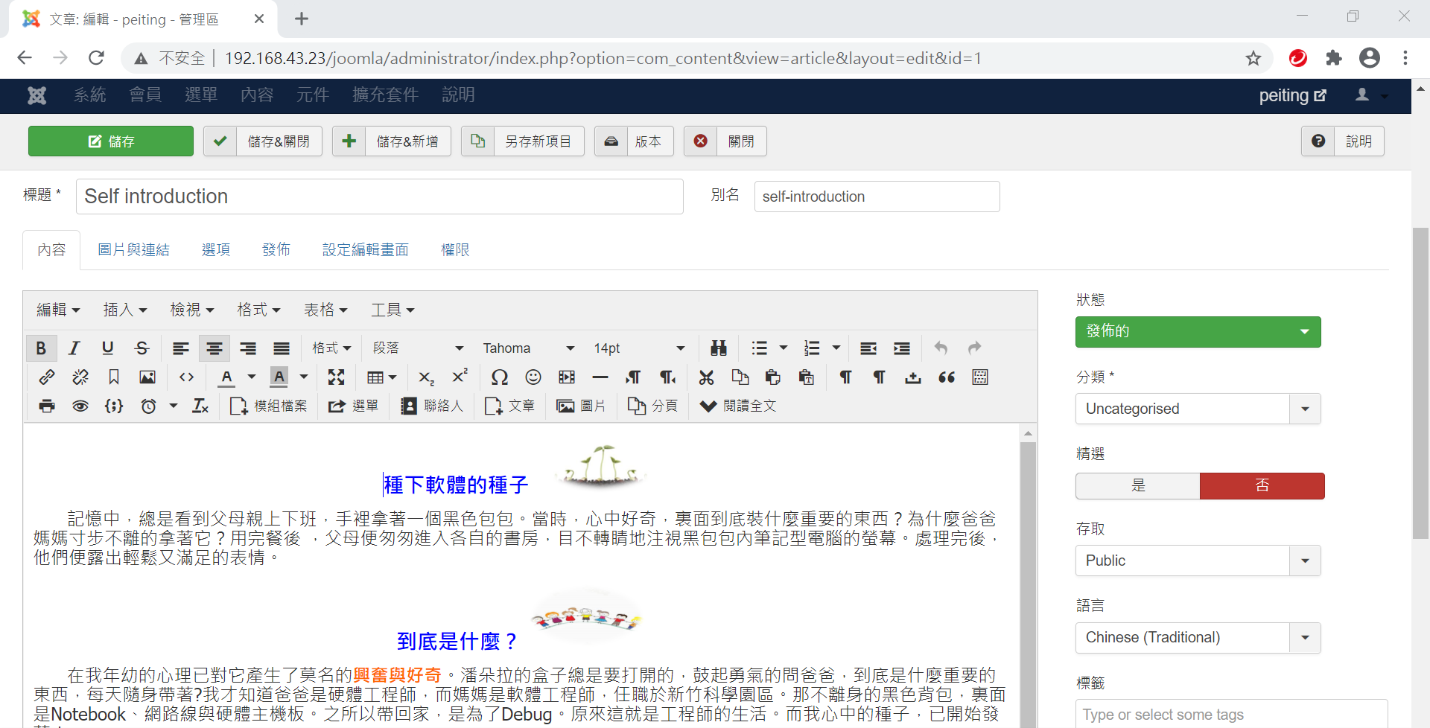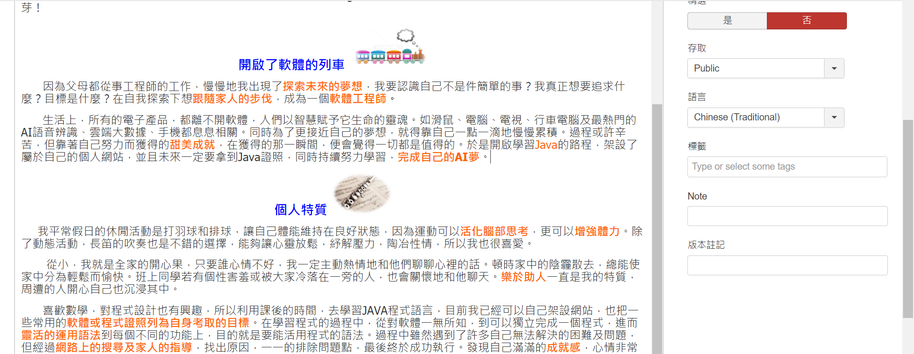

-Any suggestion about this class

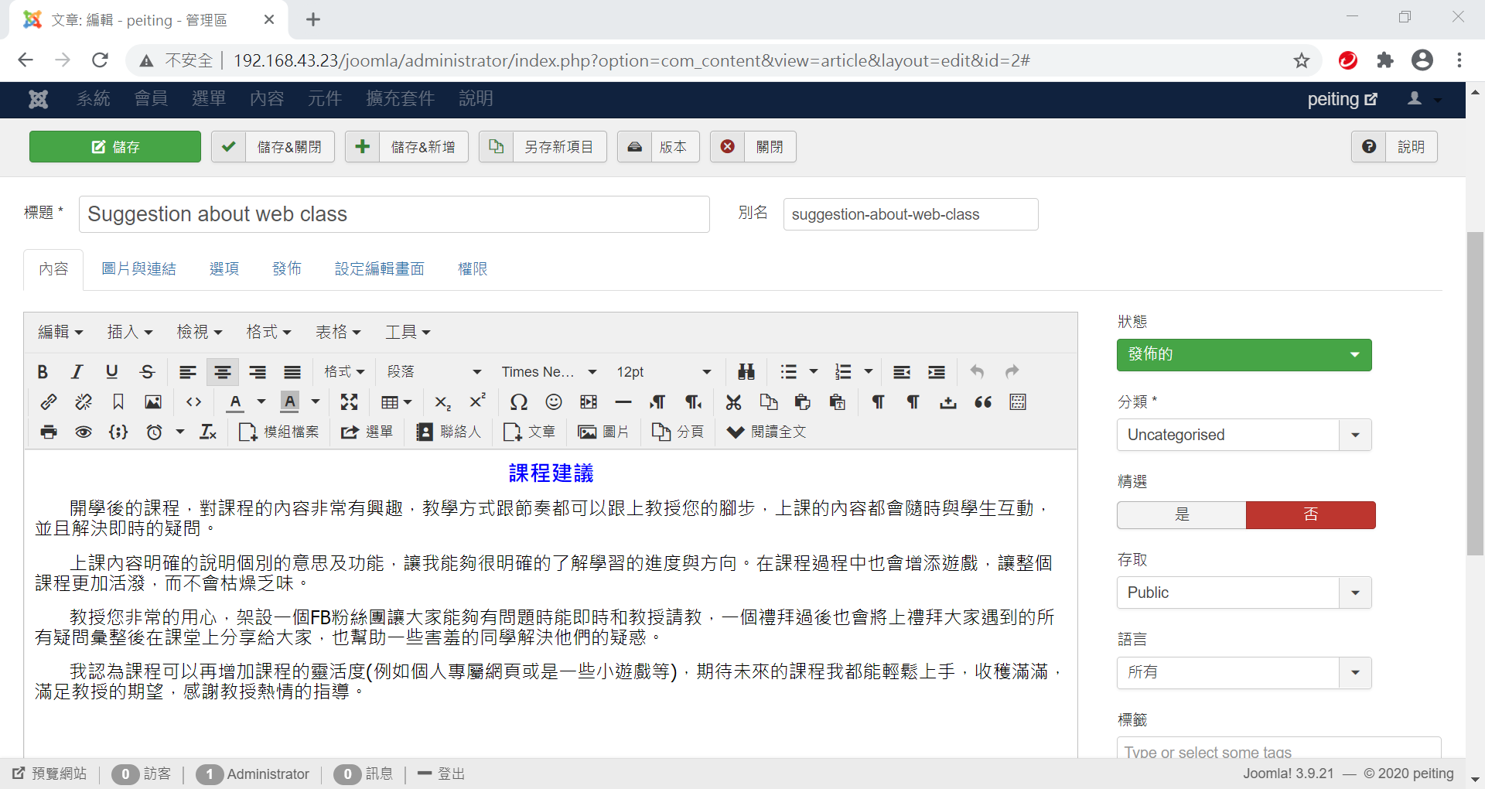

Bonus

˙Register hostname (no-ip)

